**Initialization: caled upon the bean immediately.**

**destruction: called just before the bean is removed from the container**

Interface which can be used which is an old method.

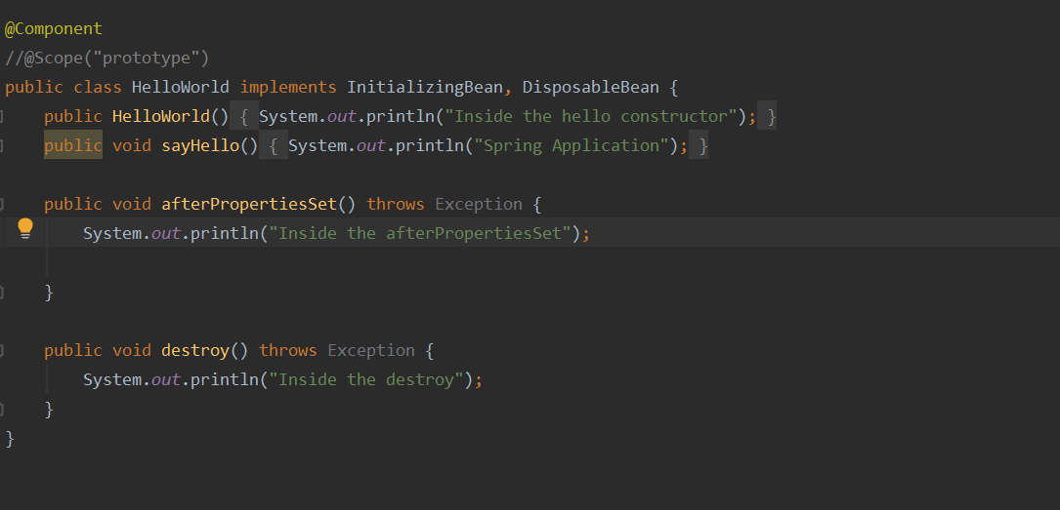

There are annotations which can override these.

@PostConstruct

@PreDestroy

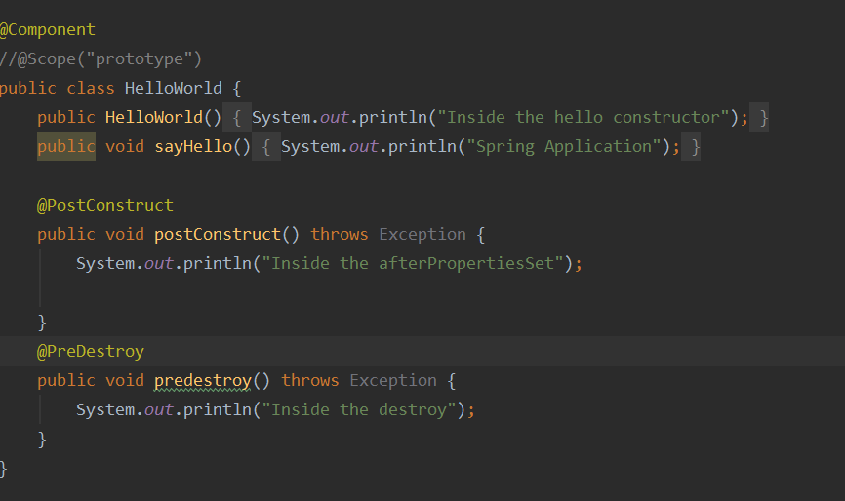

Output of both:

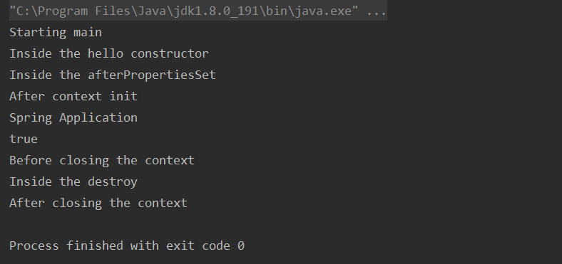

**3 types of dependency injections**

**Multiple Components/ Components Dependency**

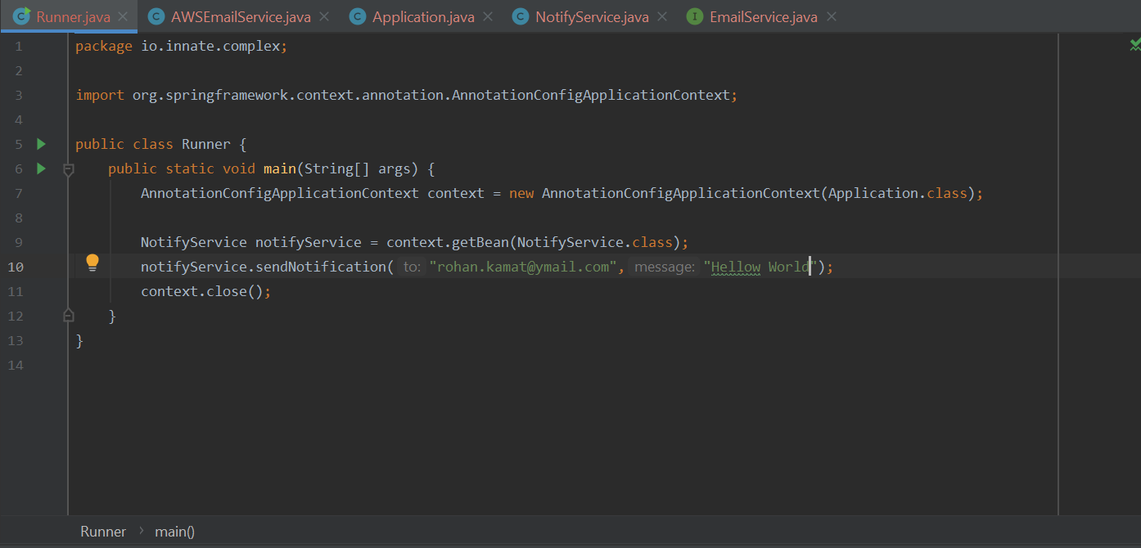

**Constructor based DI**

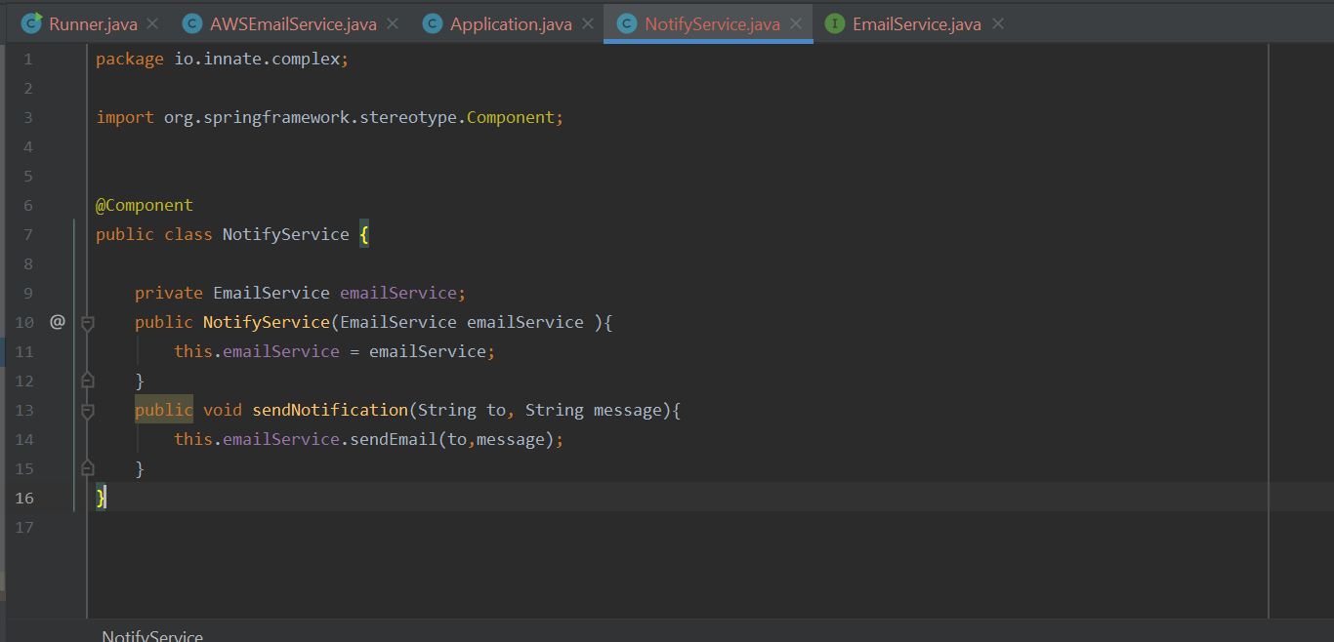

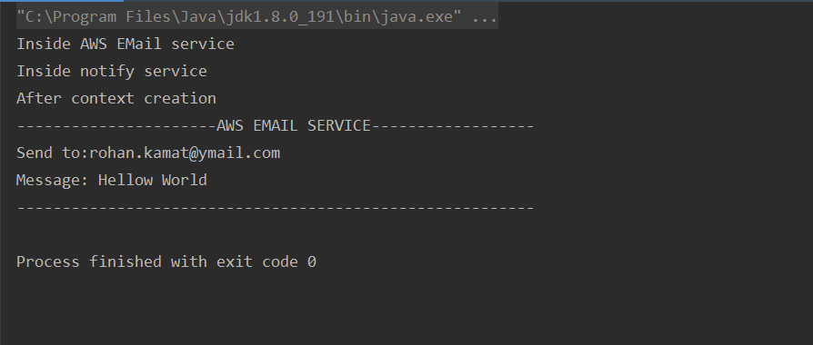

Spring finds multiple components here the email service is depended on AWSEmailService.

**Mark Dependency as optional.**

@Autowired(Required=false)

**Cyclic dependencies**

Use a setter and set autowired

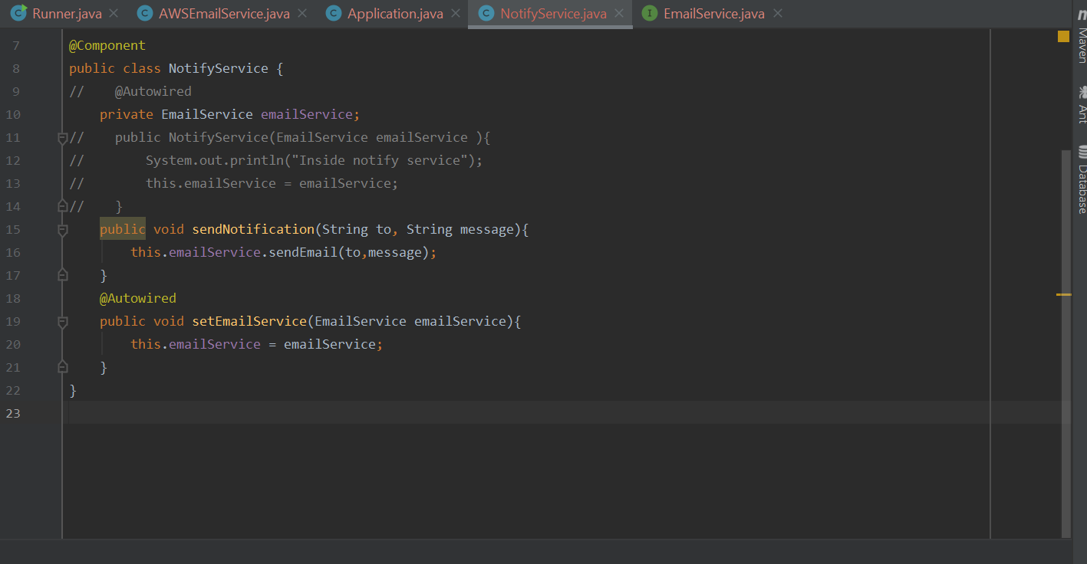

**Concept of qualifiers**

Multiple services

